CHAPTER FOUR

SYSTEM IMPLEMENTATION, TESTING AND RESULTS

4.1 Introduction
This chapter presents the implementation, testing, and results of the Web-Based E-Post Management System. The system was developed to provide an electronic platform for managing organizational correspondence, including registration, storage, assignment, routing, tracking, notification, search, and reporting.
The system was implemented using Node.js, Express.js, EJS, HTML, CSS, JavaScript, MongoDB, and Mongoose. The major functions implemented include user authentication, user and department management, correspondence registration, document upload, correspondence tracking, notifications, search, and reporting.

4.2 Development Environment
The system was developed using the following technologies:
Technology | Purpose
Node.js | Server-side application development
Express.js | Web application framework
EJS | Dynamic web page rendering
HTML/CSS/JavaScript | Interface development and client-side functionality
MongoDB | Database management
Mongoose | Database modelling and interaction
Visual Studio Code | Source-code development
Web Browser | System access and testing

4.3 System Implementation
The developed system provides a web-based environment through which authorized users can manage organizational correspondence electronically. The implementation covers authentication, user management, department management, correspondence registration, document upload, assignment, tracking, notifications, search, and reporting.

4.3.1 Login Interface
The login interface provides secure access to the system. Users enter their registered credentials, which are validated before access to the dashboard is granted.
Figure 4.1: Login Interface of the Web-Based E-Post Management System
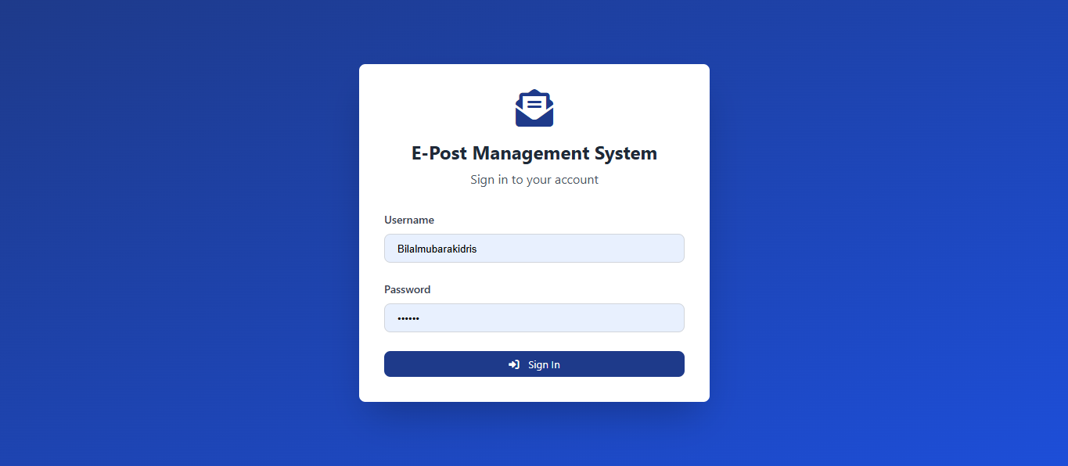
The login interface ensures that only registered users can access the system.

4.3.2 Dashboard
After successful login, users are directed to the dashboard. The dashboard provides an overview of important correspondence activities and system information.
Figure 4.2: System Dashboard

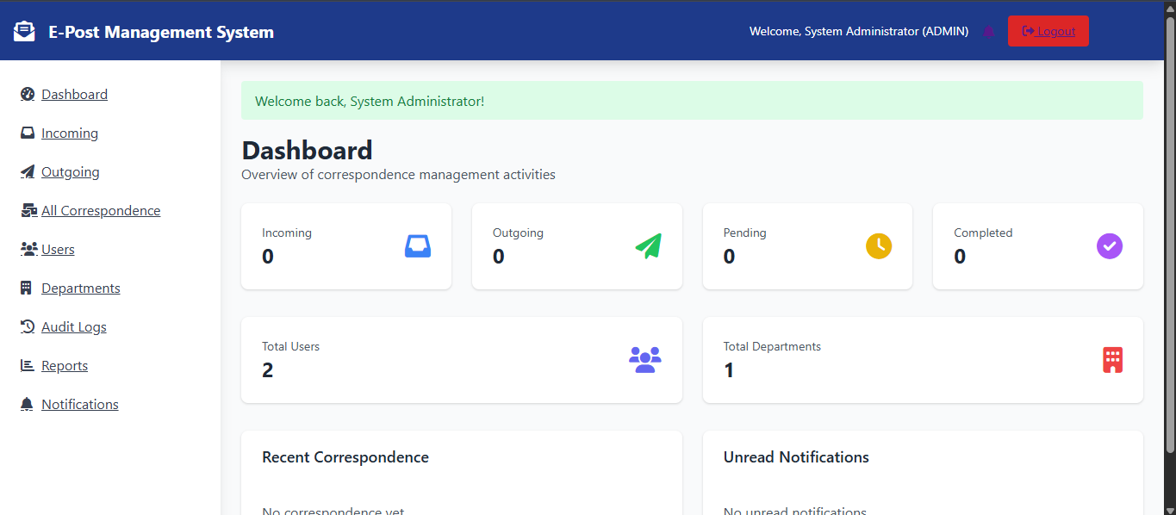
The dashboard provides a quick summary of system activities and enables users to access the major functions of the application.

4.3.3 User and Department Management
The system provides administrative functions for managing users and organizational departments. Administrators can create and update user accounts, assign roles and departments, and manage department information.
Figure 4.3: User and Department Management Interface
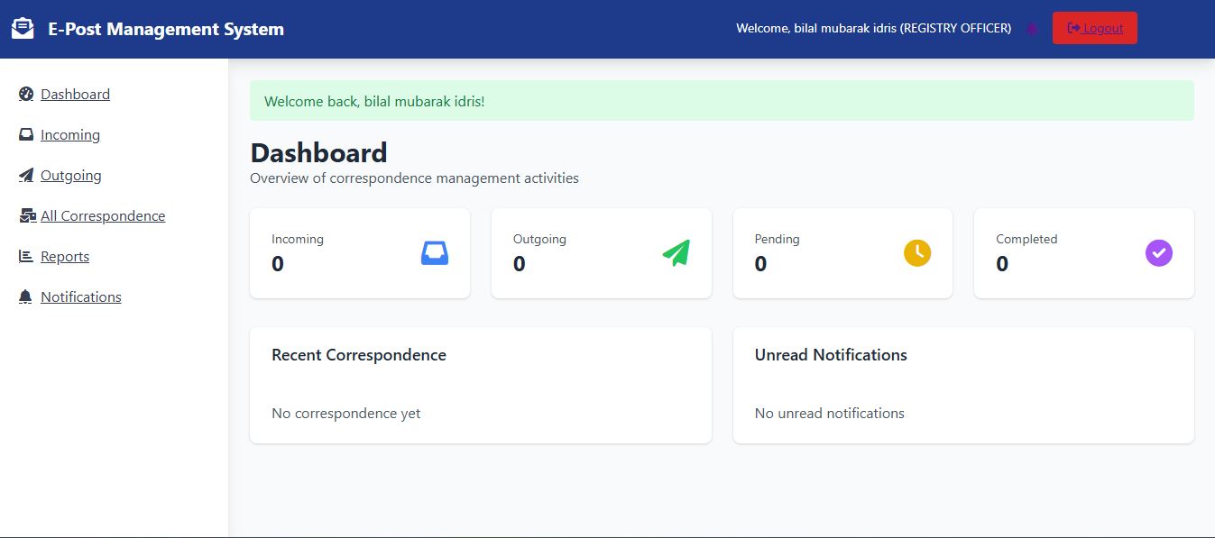
This function supports proper organization of users and access to the correspondence management system.

4.3.4 Correspondence Registration
The system allows authorized users to register both incoming and outgoing correspondence. Important information such as reference number, subject, sender or recipient, department, priority, date, description, and attachments can be recorded.
Figure 4.4: Correspondence Registration Interface
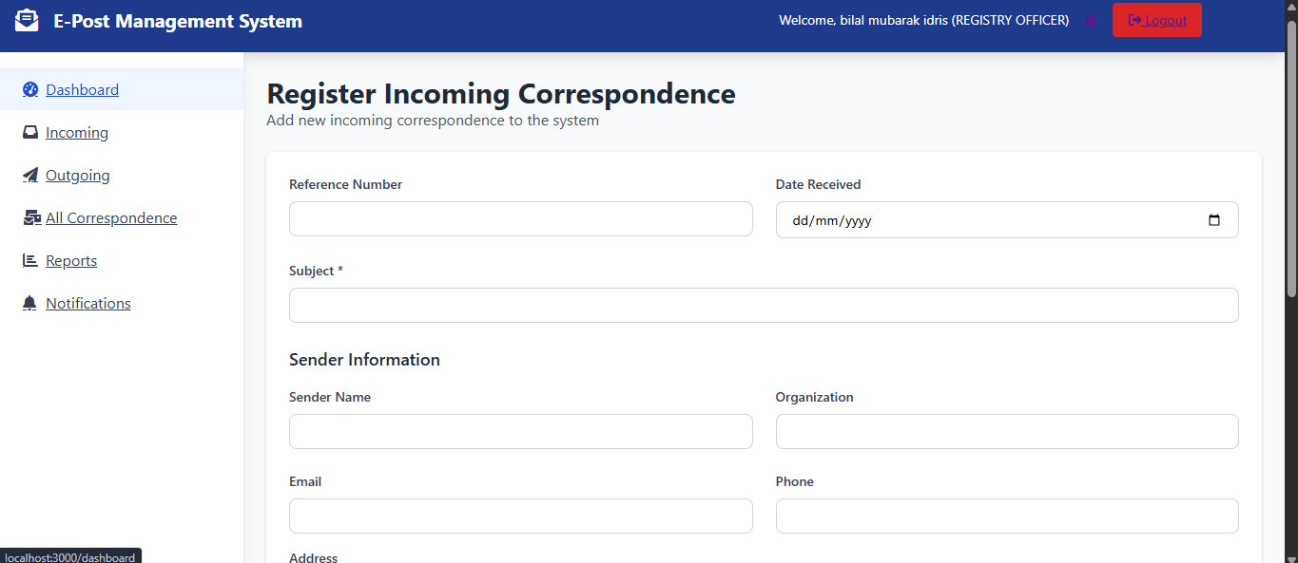
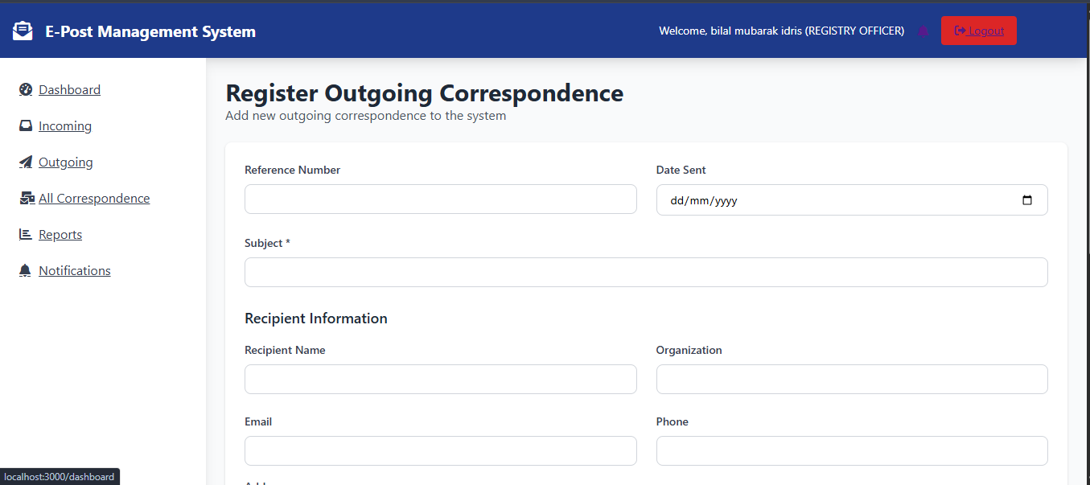
The registration function provides a centralized electronic record of organizational correspondence.

4.3.5 Correspondence Management and Tracking
Registered correspondence can be viewed and managed from the correspondence interface. Users with appropriate permissions can view correspondence details, assign correspondence to departments or users, and monitor its processing status.
Figure 4.5: Correspondence Management and Tracking Interface
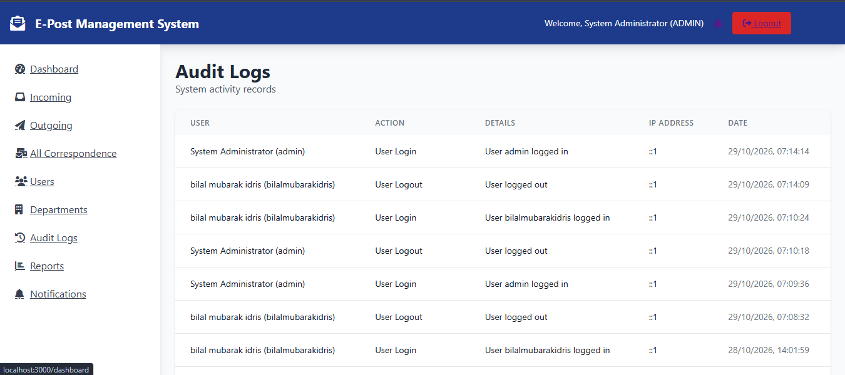
The tracking function records the movement and status of correspondence, making it easier for authorized users to determine its current processing stage.

4.3.6 Notifications and Search
The system provides notifications to inform users about correspondence activities requiring their attention. A search function is also provided to enable users to locate correspondence using information such as tracking number, reference number, subject, department, or status.
Figure 4.6: Notification and Search Interface

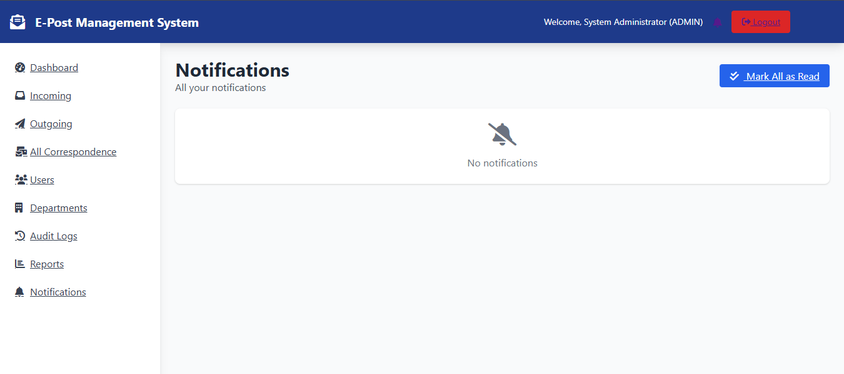
These functions improve access to correspondence and reduce the difficulty associated with manually locating documents.

4.3.7 Reports
The system provides reports that summarize correspondence activities. Reports can be generated based on available correspondence information, including incoming, outgoing, pending, completed, departmental, and tracking records.
Figure 4.7: Correspondence Reporting Interface
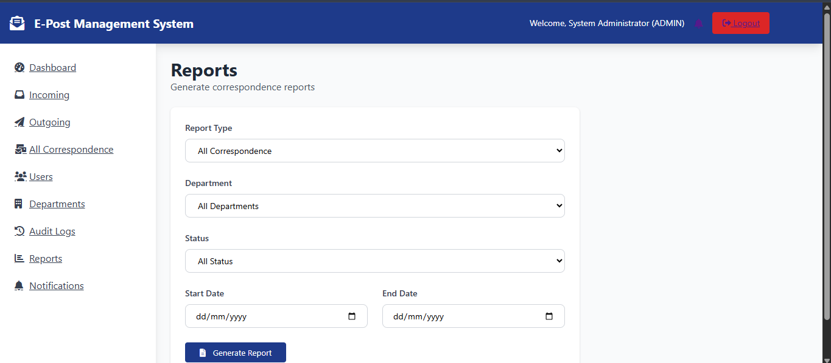
The reporting function provides useful information for monitoring correspondence activities and supporting administrative decision-making.

4.3.8 Database Implementation
MongoDB was used to store the system data. The database maintains information relating to users, departments, correspondence, attachments, tracking activities, notifications, and other system records.
Figure 4.8: Sample Database Record
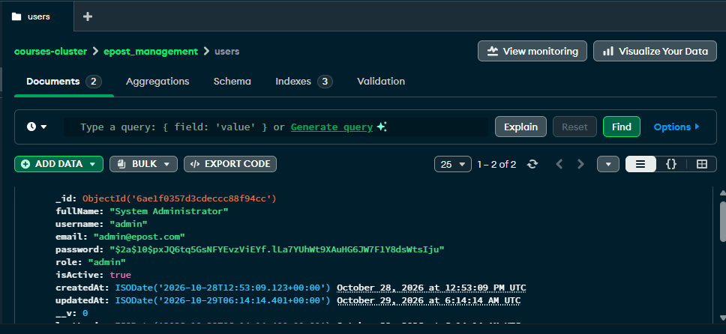The database provides centralized storage and retrieval of correspondence information.

4.4 System Testing
Testing was conducted to verify that the major functions of the developed system operated according to the specified requirements. Functional testing covered authentication, user management, correspondence registration, document upload, assignment, tracking, notifications, search, reporting, and access control.

Table 4.1: Functional Test Results
Test | Function | Expected Result | Result
TC01 | User Login | Valid credentials provide access | Pass
TC02 | Invalid Login | Invalid credentials are rejected | Pass
TC03 | User Management | User account is created successfully | Pass
TC04 | Department Management | Department is created successfully | Pass
TC05 | Correspondence Registration | Record is saved successfully | Pass
TC06 | Document Upload | Valid document is uploaded | Pass
TC07 | Correspondence Assignment | Correspondence is assigned successfully | Pass
TC08 | Tracking | Correspondence history is displayed | Pass
TC09 | Notification | Notification is generated | Pass
TC10 | Search | Matching correspondence is displayed | Pass
TC11 | Report | Required report is generated | Pass
TC12 | Access Control | Unauthorized access is rejected | Pass
TC13 | Logout | User session is terminated | Pass
Note: The results should only be marked "Pass" after the corresponding tests have actually been performed.

4.5 Security Testing
Security testing focused on ensuring that unauthorized users could not access protected system resources. The major security checks included invalid login attempts, unauthorized access to restricted pages, role-based access, logout, and unauthorized document access.
The tests confirmed that access to protected functions is controlled through authentication and user permissions.

4.6 Results of the Developed System
The implementation resulted in a centralized web-based platform for managing organizational correspondence. The major results of the system include:
- Electronic Registration: Incoming and outgoing correspondence can be registered electronically.
- Centralized Storage: Correspondence information and electronic documents can be stored centrally.
- Routing and Assignment: Correspondence can be assigned to appropriate departments or users.
- Tracking: The system records correspondence movement and processing status.
- Notifications: Users can receive notifications concerning correspondence activities.
- Search and Retrieval: Authorized users can quickly locate correspondence records.
- Reporting: The system can generate correspondence reports.
- User Management: Administrators can manage users and access privileges.
These functions address major difficulties associated with manual correspondence management, particularly document retrieval, tracking, storage, and communication.

4.7 Discussion of Results
The developed system provides an electronic alternative to several manual correspondence management activities. Instead of relying entirely on physical files, correspondence can be registered, stored, assigned, tracked, and retrieved electronically.
The search functionality makes it easier to locate correspondence using relevant information such as tracking number, reference number, subject, department, or status. The tracking functionality also provides visibility into the movement and processing status of correspondence.
Furthermore, authentication and role-based access help restrict system functions according to user responsibilities. Notifications and reports provide additional support for monitoring correspondence activities.

